Alphabetic Writing system

What is Alphabetic Writing system
# Source: AI Source: Provided by: [Data Path: Persons Table -> ID Column: 1, Name_En Column: Motasem Essam] -> From: [Chatgpt (GPT-4-turbo)] on [7/21/2025]
An alphabetic writing system is a type of writing system in which symbols (called letters) represent individual sounds (phonemes) of a spoken language. These sounds are combined to form syllables, words, and sentences.

🔤 Key Features of Alphabetic Writing Systems:
# Source: AI Source: Provided by: [Data Path: Persons Table -> ID Column: 1, Name_En Column: Motasem Essam] -> From: [Chatgpt (GPT-4-turbo)] on [7/21/2025]
- Letters Represent Sounds
  - Each letter typically corresponds to a consonant or vowel sound.
  - Example: The word "cat" has three letters and three sounds: /k/, /æ/, /t/.
- Fixed Set of Symbols (Alphabet)
  - The alphabet is a standardized set of characters.
  - Example: The English alphabet has 26 letters (A–Z).
- Direction of Writing
  - Most alphabetic systems are written left to right, though some (like Arabic or Hebrew) are written right to left.

✍️ Examples of Alphabetic Writing Systems:
# Source: AI Source: Provided by: [Data Path: Persons Table -> ID Column: 1, Name_En Column: Motasem Essam] -> From: [Chatgpt (GPT-4-turbo)] on [7/21/2025]

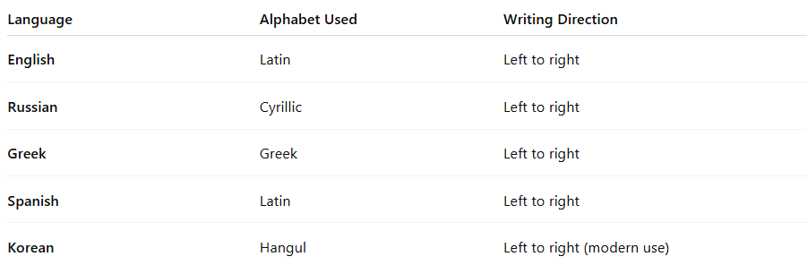

Language | Alphabet Used | Writing Direction
English | Latin | Left to right
Russian | Cyrillic | Left to right
Greek | Greek | Left to right
Spanish | Latin | Left to right
Korean | Hangul | Left to right (modern use)

✅ Advantages:
# Source: AI Source: Provided by: [Data Path: Persons Table -> ID Column: 1, Name_En Column: Motasem Essam] -> From: [Chatgpt (GPT-4-turbo)] on [7/21/2025]
- Efficient for representing a wide range of sounds.
- Flexible for writing new or foreign words.
- Easier to learn than logographic systems (like Chinese), since fewer symbols are needed.

⚠️ Notes:
# Source: AI Source: Provided by: [Data Path: Persons Table -> ID Column: 1, Name_En Column: Motasem Essam] -> From: [Chatgpt (GPT-4-turbo)] on [7/21/2025]
- Not all alphabetic systems are "perfectly phonetic." For example:
  - In English, letters often represent multiple sounds (e.g., "a" in cat, cake, call).
  - Some sounds are represented by letter combinations (e.g., "sh" in ship).

Summary:
# Source: AI Source: Provided by: [Data Path: Persons Table -> ID Column: 1, Name_En Column: Motasem Essam] -> From: [Chatgpt (GPT-4-turbo)] on [7/21/2025]
An alphabetic writing system uses a set of letters to represent the basic sounds (phonemes) of a language. It's one of the most widely used systems in the world due to its simplicity and adaptability.

